**Problem 1**

**Load the dataset**



**Now check if our data is loaded correctly using dump command**

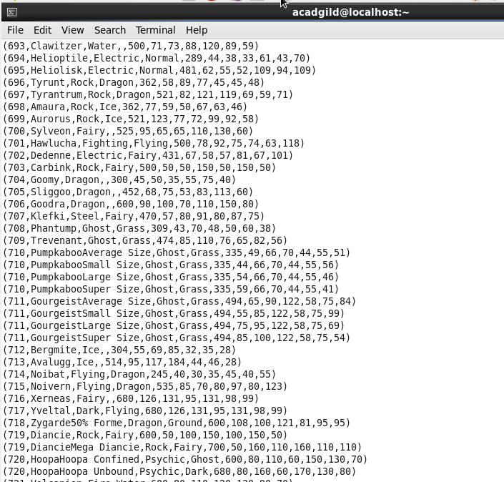

3)

**Now we filter thee data based on whose defense is greater than 55**



**OUTPUT**

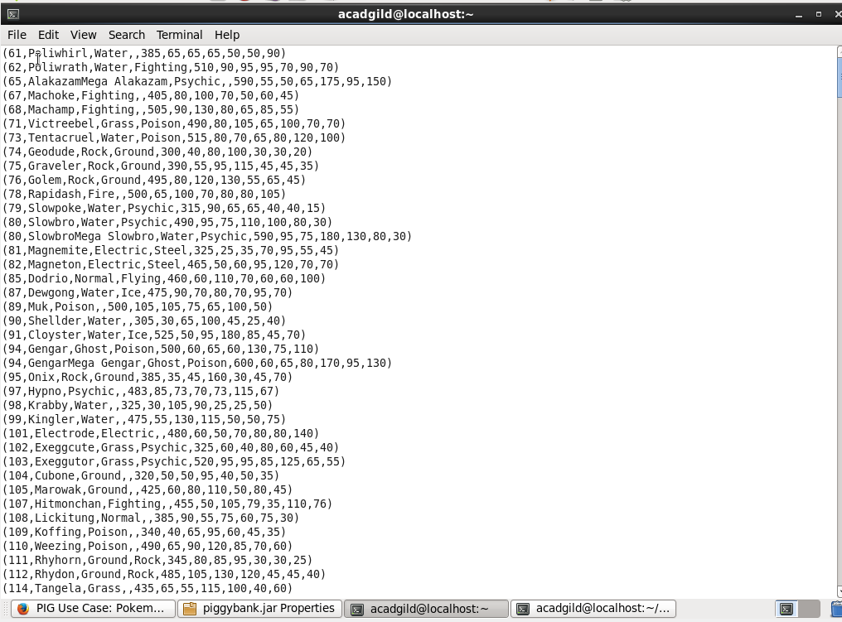

**Problem 2**

**We will group the data and count the numbers of players are eligible**

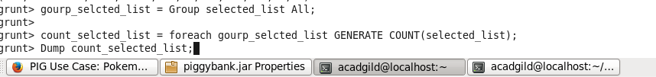

**OUTPUT**

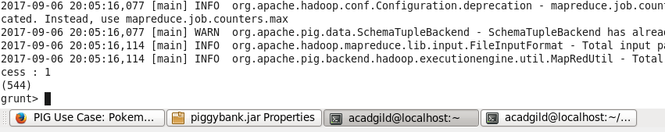

**Problem 3**

**generate random numbers for each Pokémon on the selected list.**



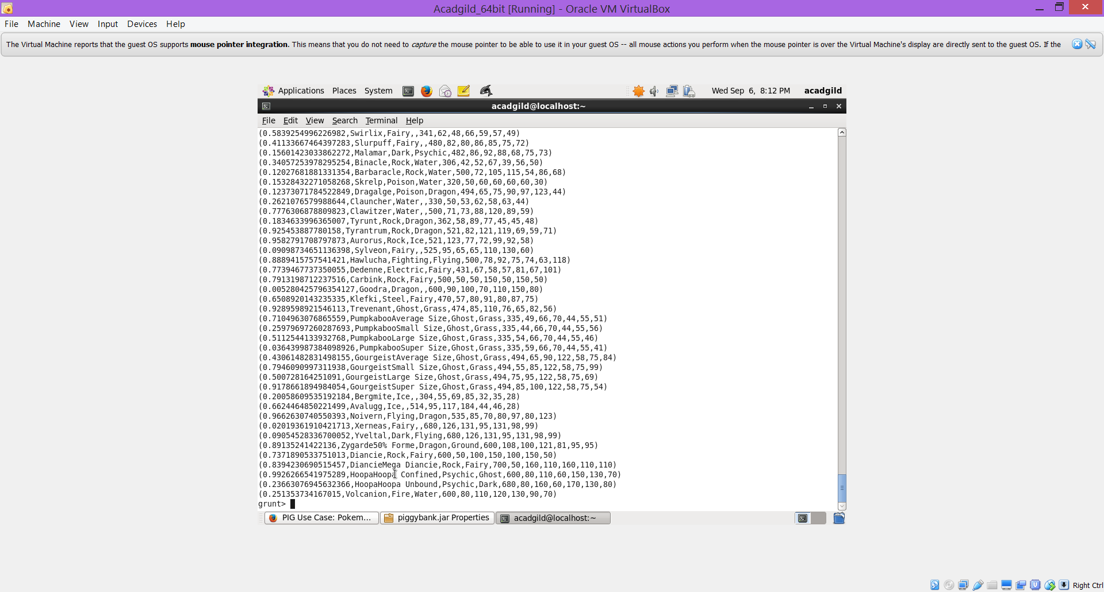

**Problem 4**

**NOW Order this LIST in Descending Order**

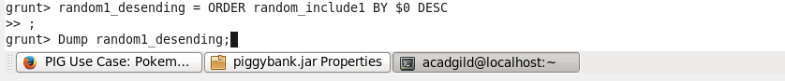

OUTPUT

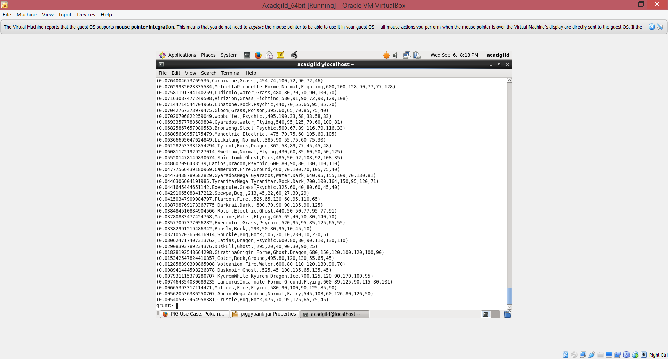

**We need another list to form a team so we will repeat the same process. As in above 2 steps generate random number and order it in descing order**

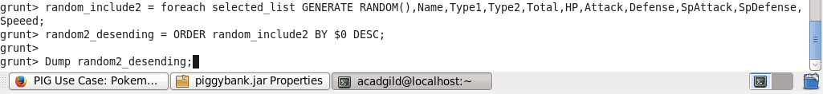

**OUTPUT**

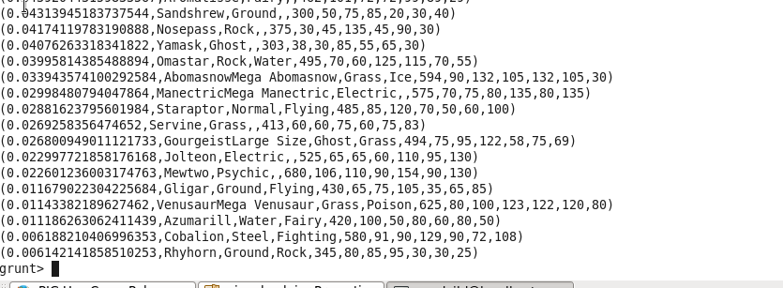

**Now we limit the data as we need only 5 different pokemon for 2 players**

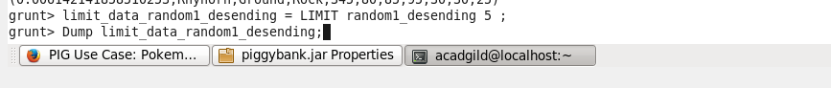

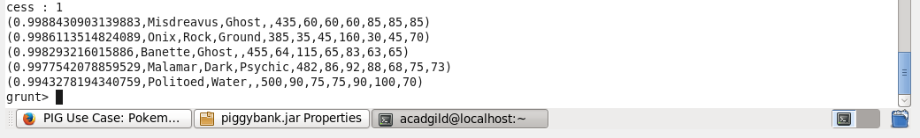

**Repeat the same steps as above**



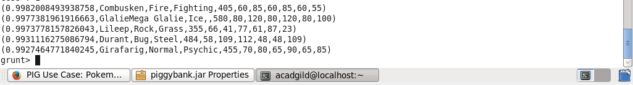

**Store the data in local drive for final match by name and HP**



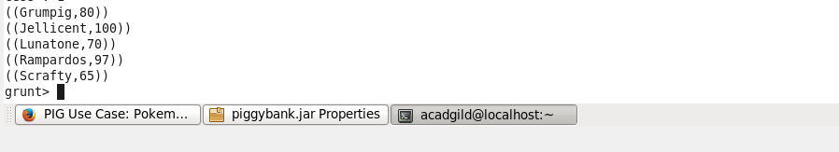

**Repeat the same steps as above**

